Praveen kumar yadav

(MTech VLSI Sem 1, EE22M308)

Lab no. : 3

Used version: Matlab 2022

Ans No 1

ANS NO 1a

Q1;

Q.1:- Use finite difference method to solve the Schrodinger’s equation for a particle in a 1D box with mass same as that of an electron and well width of 10 nm. Use 101 points for discretization. Plot the energy values vs the eigenvalue number and compare it with the analytical results. Also plot the probability distribution for eigenvalues 1 and 25. Instead of 101 points, use 1001 points for discretization and redraw the plots. What effect do you see? Also check if the wavefunction you are getting is normalized.

Ans:

FDM:

For 101 points

clear all;

clc;

q=1.6*(10)^(-19);

m=9.1*10^(-31);

pie=3.14;

h=6.62*1*10^(-34);

a=10*10^(-9);

j=a/100

t0=-((h/(2*pie))^2)/(2*m*((j)^2))/q;

EVN=[];

for i=1:1000

H(i,i)=-2*t0 ;

EVN = [EVN, i];

end

for i=1:999

H(i,i+1)=t0;

end

for i=1:999

H(i+1,i)=t0;

end

[V,D] = eig(H);

EV = diag(D);

EVT = EV;

plot(EVN,EV);

xlabel('eigen value no');

ylabel('eigen value');

title('energy values vs the eigen value no');

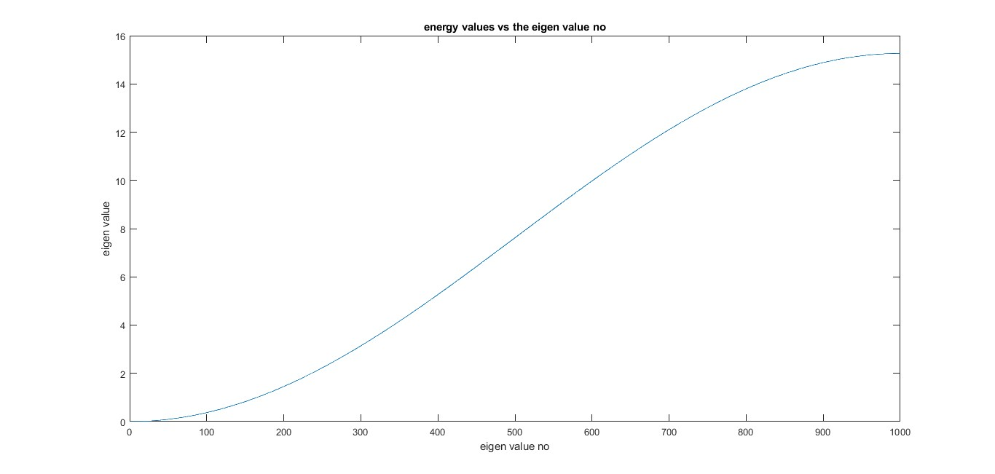

Analytical :

clc;

m=9.1*10^(-31);

q=1.6*10^(-19);

h=6.62*1*10^(-34);

a=10*10^(-9);

EN=[];

for i=1:99

E=(((i*h)/a)^2)/(8*m*q);

EN =[EN,E];

end

disp(EN);

i=1:99;

plot(i,EN)

xlabel('eigen value no i');

ylabel('energy value');

title('energy value vs eigen value graph by analytical');

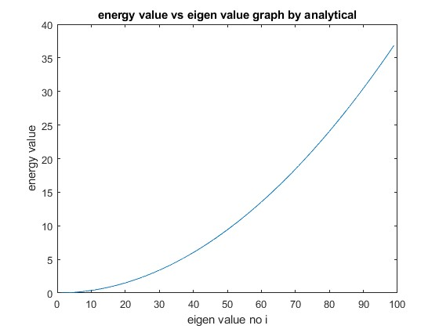

Pdf:

For eigen value 1

clear all;

clc;

q=1.6*(10)^(-19);

aifsilon=8.85*(10)^(-12);

m=9.1*10^(-31);

h=6.62*1*10^(-34);

h_fn=h/(2*3.14);

a=1*10^(-10);

t0=-(h_fn^2)/(2*m*a*a);

for i=1:100

H(i,i)=(-(2*t0)+(q^2)/(4*pi*aifsilon*i));

end

for i=1:99

H(i,i+1)=t0;

end

for i=1:99

H(i+1,i)=t0;

End

[V,D] = eig(H);

EV = diag(D);

i=1:100;

plot(i,EV)

f1=[];

V(1:99,1);

f1=[f1,V(1:99,1)];

subplot(2,1,1)

i=1:99;

plot(i,f1.*f1)

xlabel('i');

ylabel('probability distribution function');

title('pdf for eigen value 1');

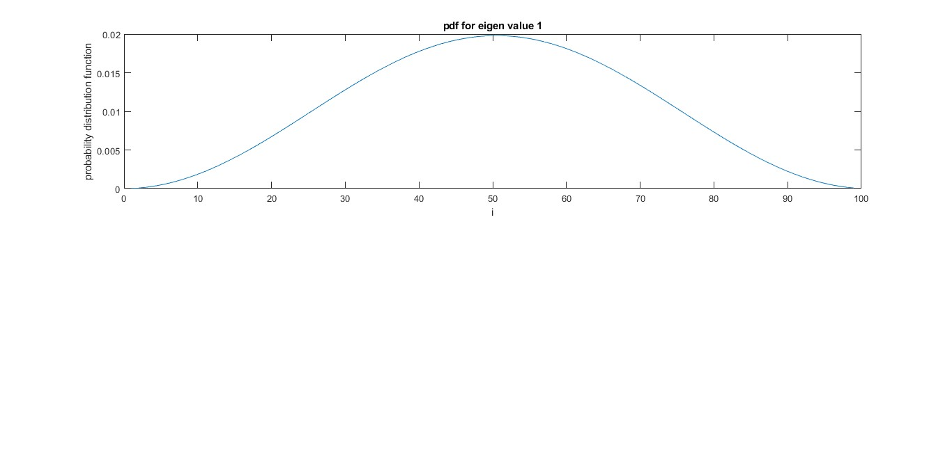

Pdf for eigen value 25

clear all;

clc;

q=1.6*(10)^(-19);

aifsilon=8.85*(10)^(-12);

m=9.1*10^(-31);

h=6.62*1*10^(-34);

h_fn=h/(2*3.14);

a=1*10^(-10);

t0=-(h_fn^2)/(2*m*a*a);

for i=1:100

H(i,i)=(-(2*t0)+(q^2)/(4*pi*aifsilon*i));

end

for i=1:99

H(i,i+1)=t0;

end

for i=1:99

H(i+1,i)=t0;

end

[V,D] = eig(H);

EV = diag(D);

i=1:100;

plot(i,EV)

f1=[];

V(1:99,25);

f1=[f1,V(1:99,25)];

subplot(2,1,1)

i=1:99;

plot(i,f1.*f1)

xlabel('i');

ylabel('probability distribution function');

title('pdf for eigen value 25');

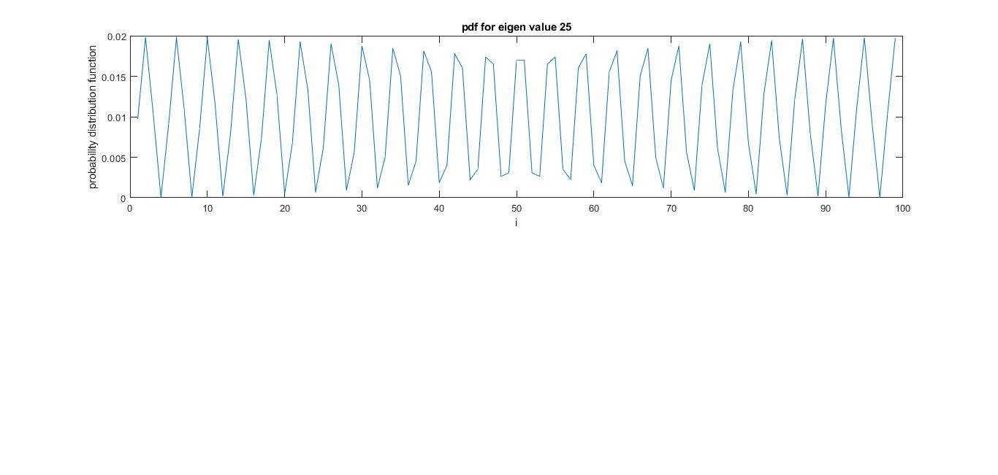

FOR 1001 POINTS

ENERGY VS EIGEN VALUE GRAPH

clear all;

clc;

q=1.6*(10)^(-19);

m=9.1*10^(-31);

pie=3.14;

h=6.62*1*10^(-34);

a=10*10^(-9);

j=a/1000

t0=-((h/(2*pie))^2)/(2*m*((j)^2))/q;

EVN=[];

for i=1:1000

H(i,i)=-2*t0 ;

EVN = [EVN, i];

end

for i=1:999

H(i,i+1)=t0;

end

for i=1:999

H(i+1,i)=t0;

end

[V,D] = eig(H);

EV = diag(D);

EVT = EV;

plot(EVN,EV);

xlabel('eigen value no');

ylabel('eigen value');

title('For 1001 point, energy values vs the eigen value no ');

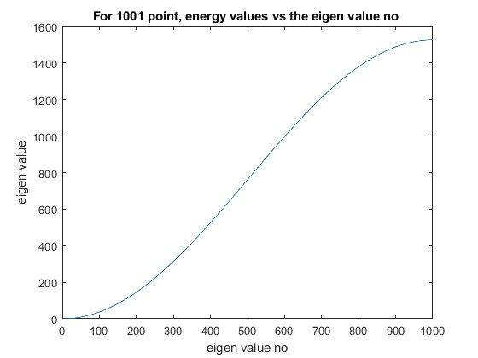

ANALYTICAL

clc;

m=9.1*10^(-31);

q=1.6*10^(-19);

h=6.62*1*10^(-34);

a=10*10^(-9);

EN=[];

for i=1:99

E=(((i*h)/a)^2)/(8*m*q);

EN =[EN,E];

end

disp(EN);

i=1:99;

plot(i,EN)

xlabel('eigen value no i');

ylabel('energy value');

title('energy value vs eigen value graph by analytical');



PDF FOR 1001 POINTS

FOR EIGEN VALUE 1

clear all;

clc;

q=1.6*(10)^(-19);

aifsilon=8.85*(10)^(-12);

m=9.1*10^(-31);

h=6.62*1*10^(-34);

h_fn=h/(2*3.14);

a=1*10^(-11);

t0=-(h_fn^2)/(2*m*a*a);

for i=1:1000

H(i,i)=(-(2*t0));

end

for i=1:999

H(i,i+1)=t0;

end

for i=1:999

H(i+1,i)=t0;

end

[V,D] = eig(H);

EV = diag(D);

i=1:1000;

plot(i,EV)

f1=[];

V(1:999,1);

f1=[f1,V(1:999,1)];

subplot(2,1,1)

i=1:999;

plot(i,f1.*f1)

xlabel('i');

ylabel('probability distribution function');

title('FOR 1000: pdf for eigen value 1');

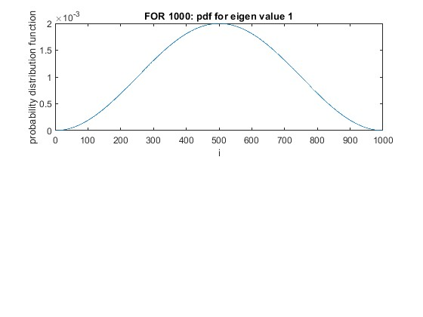

PDF FOR EIG 25

clear all;

clc;

q=1.6*(10)^(-19);

aifsilon=8.85*(10)^(-12);

m=9.1*10^(-31);

h=6.62*1*10^(-34);

h_fn=h/(2*3.14);

a=1*10^(-11);

t0=-(h_fn^2)/(2*m*a*a*q);

for i=1:1000

H(i,i)=-(2*t0);

end

for i=1:999

H(i,i+1)=t0;

end

for i=1:999

H(i+1,i)=t0;

end

[V,D] = eig(H);

EV = diag(D);

i=1:1000

plot(i,EV);

f1=[];

V(1:999,25);

f1=[f1,V(1:999,25)];

subplot(2,1,1);

i=1:999;

plot(i,f1.*f1)

xlabel('i');

ylabel('probability distribution function');

title('pdf for eigen value 25');

